Key Insights
(i) Stock trend
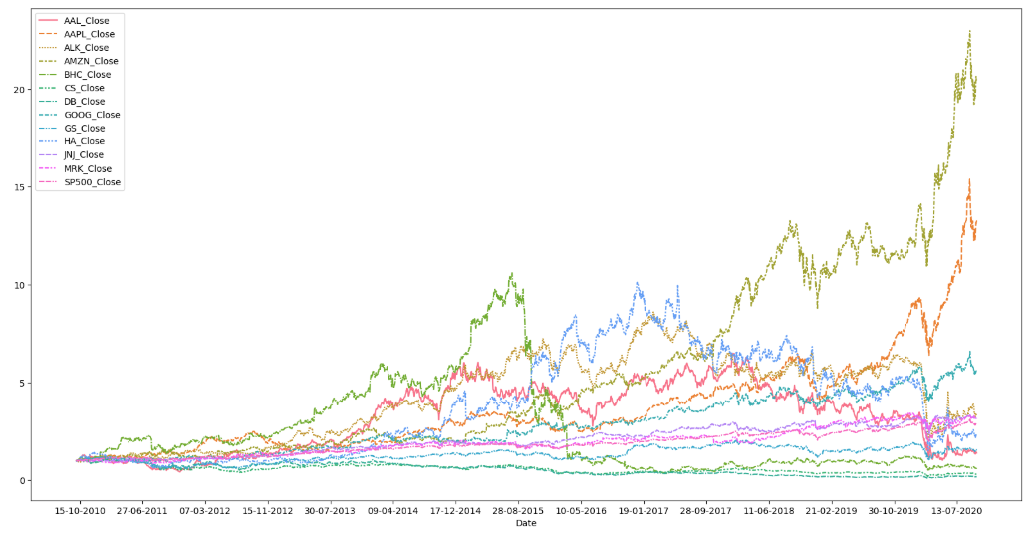
Index is in uptrend and the stocks that are in:
1. Uptrend: Apple, Amazon, Google, Goldman Sachs, J&J, Merck & Co
2. No trend / sideways: Hawaiian Holdings
3. Downtrend: American Airlines, Alaska Air, Bausch Health, Credit Suisse, Deutsche Bank
Stocks in down trend are to be avoided. Focus should be only on stocks that are in an Uptrend.

(ii) Correlation
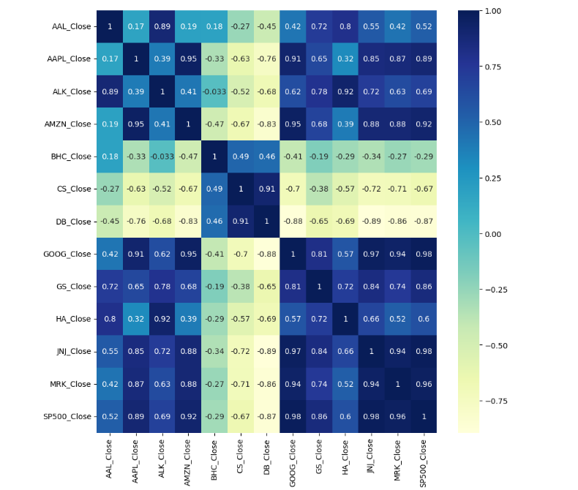
Index is in an uptrend and these stocks have the following correlation:
1. Strong Positive Correlation (0.6 to 1): Apple, Amazon, Google, Goldman Sachs, J&J, Merck & Co
2. Weak Positive Correlation (0 to 0.6): American Airlines, Alaska Air, Hawaiian Holdings
3. Negative Correlation (0 to -1): Bausch Health, Credit Suisse, Deutsche Bank
Stocks with positive correlation are recommended during the advancing phase of market cycle / index, whilst stocks with negative correlation should be avoid during this phase.
(iii) CAPM
Since Alexa is conservative and wants stable returns, so target would be to select stocks that have Beta close to 1 and have given consistent returns when compared to SP500 market returns.
We can select below stocks.
AAPL, AMZN, GOOG, JNJ, MRK - These stocks are from 2 sectors Tech and Healthcare. To diversify further we will choose.
GS from finance sector as this stock has given returns of 15.7 when compared to market return of 12 %.
ALK from aviation sector as Beta is only 1.2 and also has always given better returns than SP 500 and is best among the selected stocks from aviation industry.

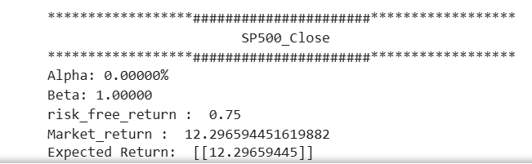

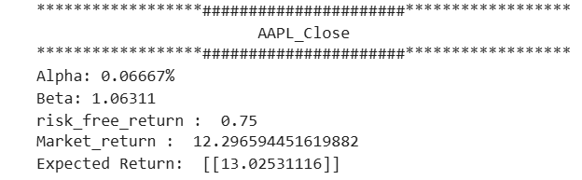
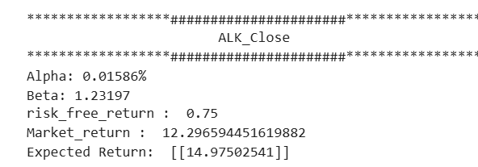
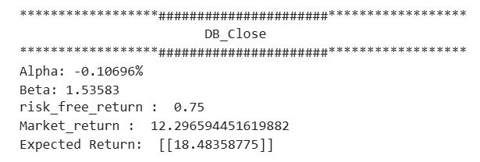
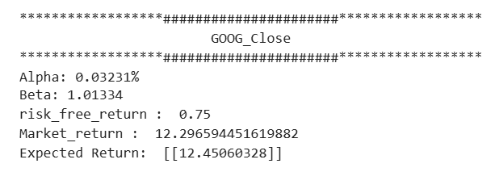
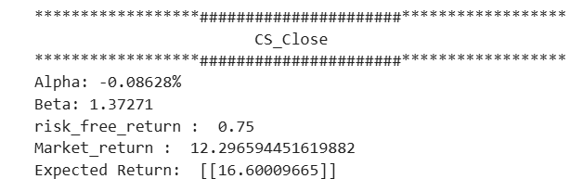
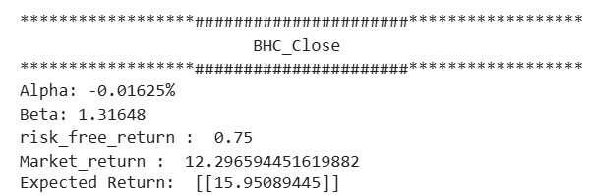
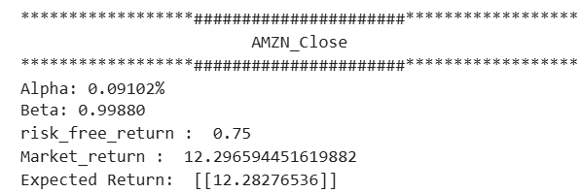
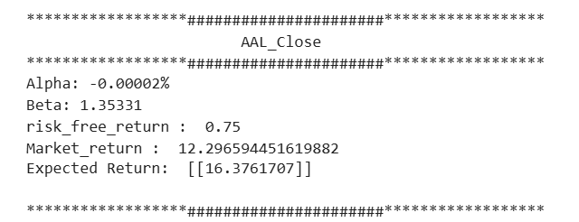

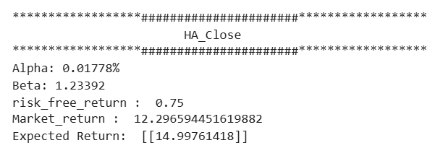
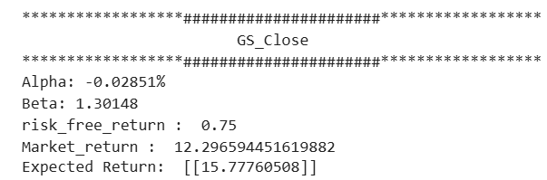

`
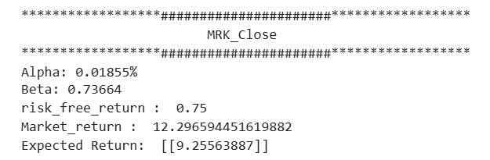
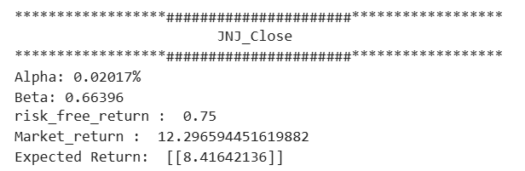

(iv) Volume Analysis

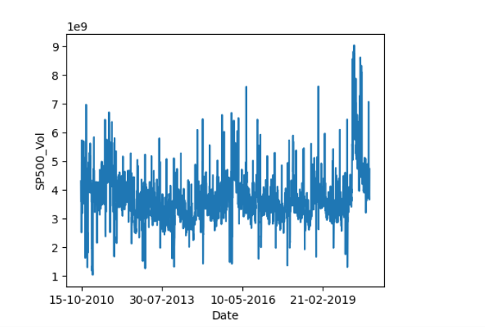
The observed peaks and troughs indicate days of high and low trading volumes across these stocks. These fluctuations could be attributed to various factors, such as state or national election results, announcements related to COVID-19 lockdowns, the release of the annual financial budget, and similar events.

(v) Sharpe Ratio

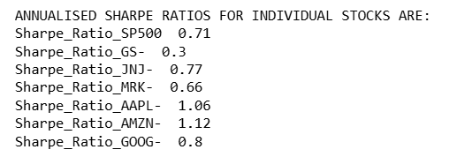

With a Sharpe Ratio of 1.12 ,1.06 ,0.8 and .77 AMZN (Amazon) ,AAPL (Apple), GOOG (Google) and JNJ (Johnson & Johnson) have performed better than SP500 (S&P 500 Index) hence they are top-performing stock in terms of risk adjusted returns.
Even though GS (Goldman Sachs) and MRK (Merck) have lower Sharpe ratio than SP500 (S&P 500 Index) but considering CAPM , the conservative approach of client and diversification of portfolio we have also taken these two in our final portfolio.

(vi) Conclusion
